Effective File and Folder Management

Describe what the following can be used for . . .

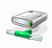
My Area

Shared Area

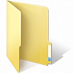How can folders be used to help you organise your work at school?

Sketch out the folder set up you will create in your area
What are the benefits of using folders?
Where could folders be used outside of school?

